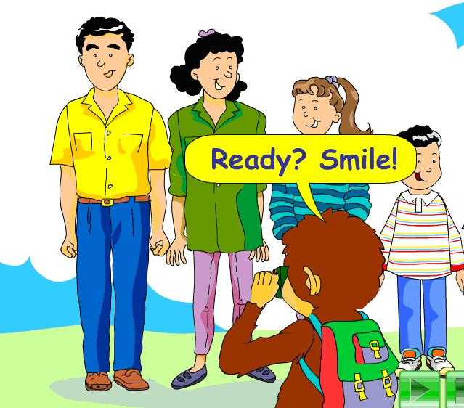
根据下边的提示，两人一组创编一个新的对话。加油呦！
Key information
A: Hi! What’s that?
B: It’s a picture of my family.
A: May I have a look?
B: Sure. Here you are.
A: How many people are there in your family?
B:
A: Who’s that ___?（boy, girl, man, woman）
B: She’s/He’s my ___.(father, mother, sister, brother) She /He is ____ years old.
A: Who are they?
B: They are my ____.(parents, sisters, brothers, uncle and aunt…)
A: Your ____ is ____, and your ____ is____.
(father, mother, sister,brother…) (tall, beautiful,pretty,strong,thin…)
B: Thanks.

